**DAILY ONLINE ACTIVITIES SUMMARY**

|  |  |  |  |  |  |  |  |  |
| --- | --- | --- | --- | --- | --- | --- | --- | --- |
| **Date:** | 27-06-2020 | | | | | **Name:** | Anvitha H M | |
| **Sem & Sec** | 4th ‘A’ | | | | | **USN:** | 4AL18CS010 | |
| **Online Test Summary** | | | | | | | | |
| **Subject** | | Data communication. | | | | | | |
| **Max. Marks** | | 30 | | **Score** | | | 25 | |
| **Certification Course Summary** | | | | | | | | |
| **Course** | Introduction to R. | | | | | | | |
| **Certificate Provider** | | | Great learning academy | | **Duration** | | | 5 hours |
| **Coding Challenges** | | | | | | | | |
| **Problem Statement:** C program to print Kth digit. | | | | | | | | |
| **Status:** Executed | | | | | | | | |
| **Uploaded the report in Github** | | | | | YES | | | |
| **If yes Repository name** | | | | | <https://github.com/alvas-education-foundation/Anvitha-H-M> | | | |
| **Uploaded the report in slack** | | | | | Yes | | | |

**Online test:**

It was from module 5 of our syllabus and the test was for 30 minutes having 30 question all multiple choice question. The questions were simple and optimal and the score that I got was 25/30.

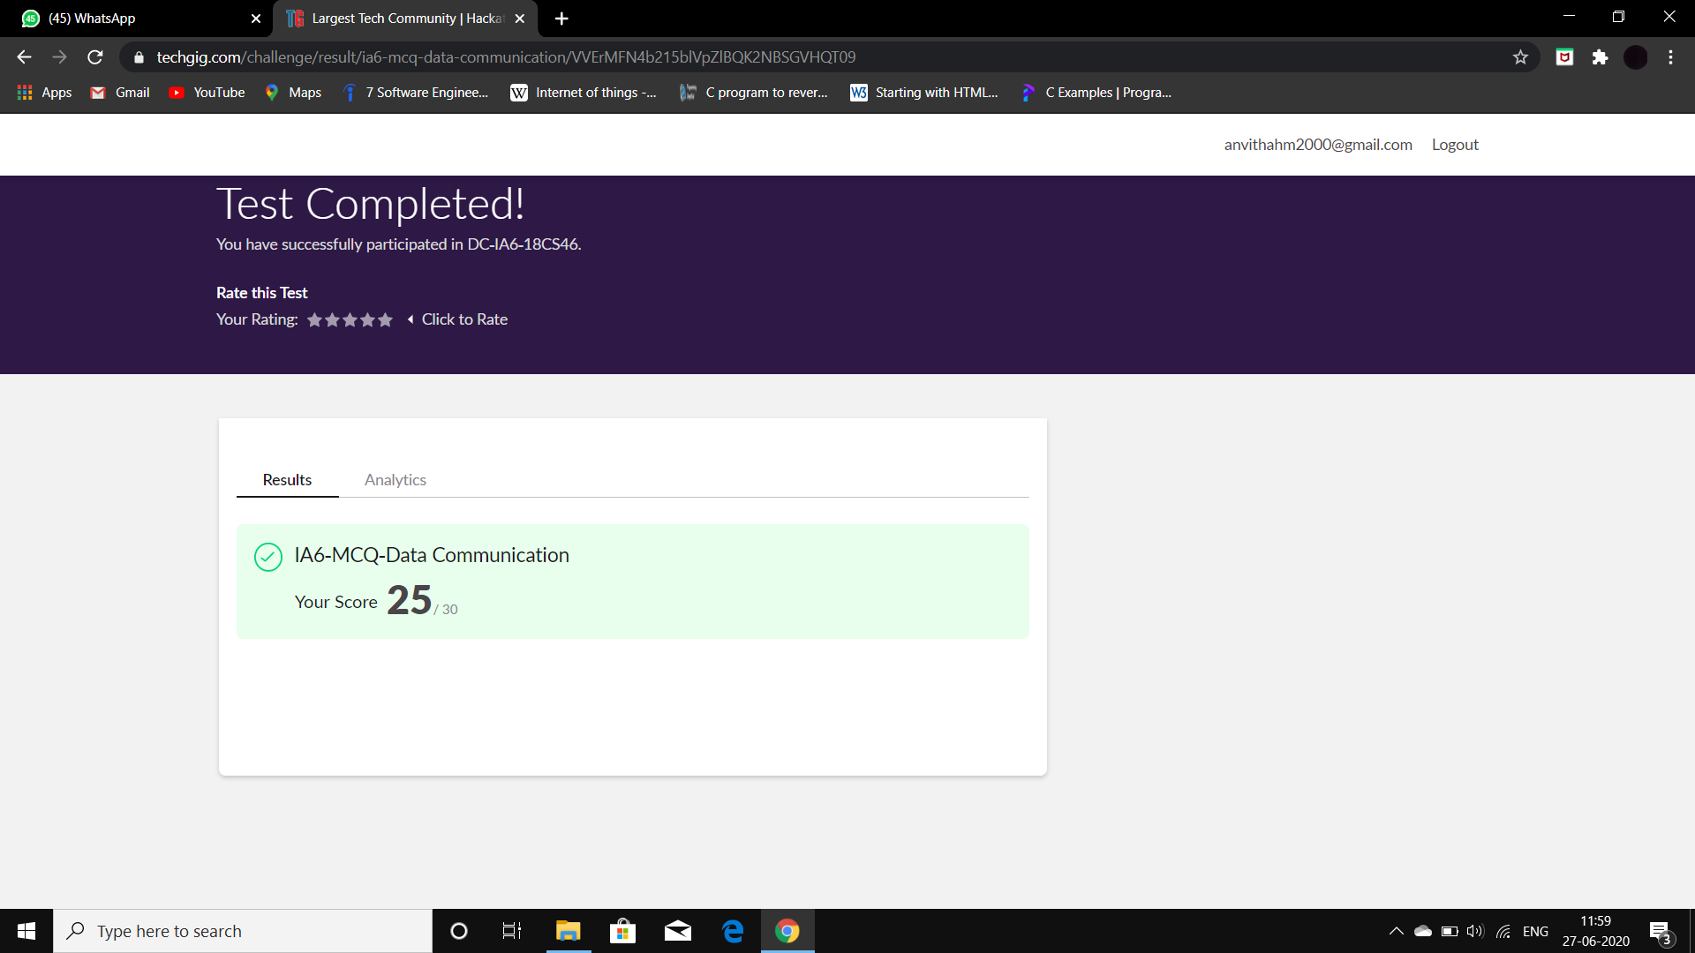

**Certification course:**

Introduction to R

The course includes detailed explanation on plots numeric, plots combination, export plots with example of case study.

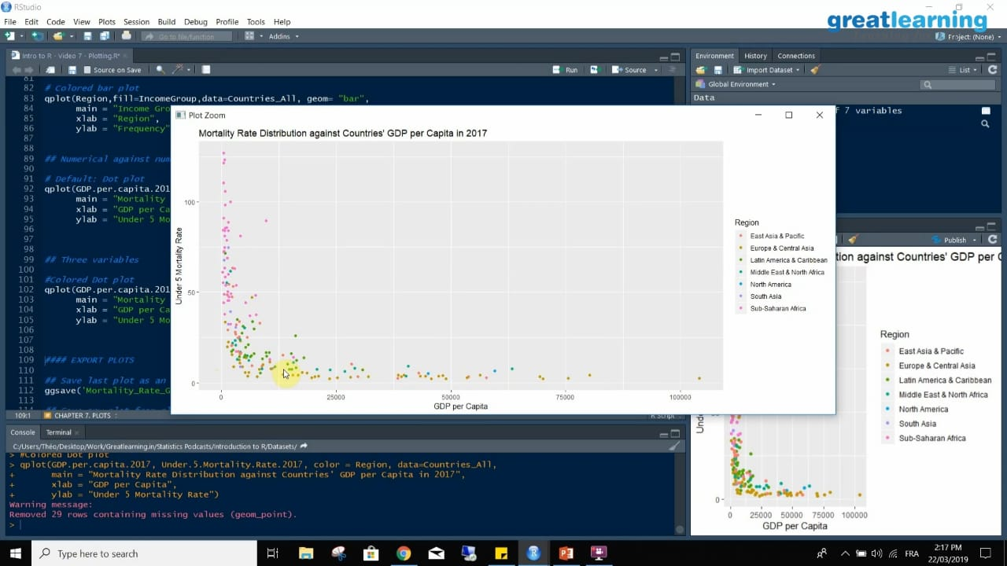

Online coding challenge

The programing statement of the day is

“C program to print Kth digit.”

Solution: Executed and uploaded in Github repository.

Link: <https://github.com/alvas-education-foundation/Anvitha-H-M>

